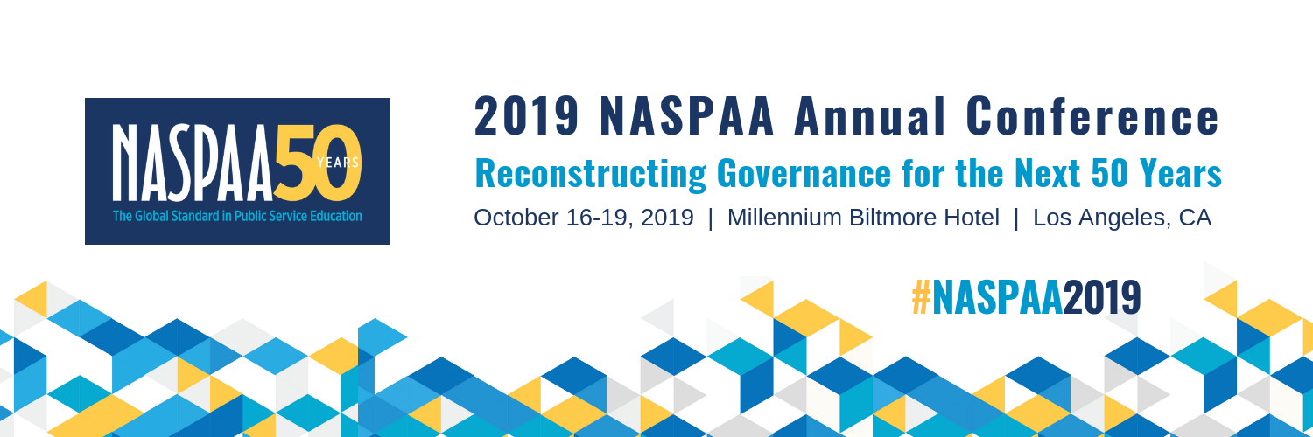

REGISTRATION FORM
NASPAA’s 2019 Annual Conference will be held in Los Angeles, CA, from October 16 - 19. Pre-conference workshops will take place on Wednesday, October 16. All panel and general sessions will occur on Thursday, October 17 and Friday, October 18. Local excursions will be on Saturday, October 19.
Conference Schedule | Registration policy | Hotel reservation
University/Company Information

University:

School:

Department:

City:
State/Province: | ZIP Code:

Country:

Attendee Information

First Name:

Last Name:

Job Title:

First name (given name) for your name badge:

Email Address:

Phone:

Registration
NASPAA Annual Conference registration rates vary depending on when you register and whether you are affiliated with a member school. Discounted registration is offered to students, members of COPRA, and to those who can attend only one day. Member refers to those who are affiliated with a NASPAA member school (including Associate members). View member list.
Mark  X | Registration Fees | Early-Bird rate ends  9/9 | Regular rate  9/10-10/4 | On-site rate  10/5-10/18
 | Member (Full access*) | $390 | $425 | $475
 | Member One-day Wednesday only | $230 | $245 | $260
 | Member One-day Thursday only | $230 | $245 | $260
 | Member One-day Friday only | $230 | $245 | $260
 | Non-member (Full access *) | $450 | $490 | $550
 | Non-member One-day Wednesday only | $255 | $275 | $295
 | Non-member One-day Thursday only | $255 | $275 | $295
 | Non-member One-day Friday only | $255 | $275 | $295
 | COPRA (Full access *) | $120 | $145 | $170
 | Student (Full access *) Student must submit a proof of student status or a professor can vouch for their status upon NASPAA approval. | $120 | $145 | $170
 | Spouse/Partner (Full access *) Note that a registrant cannot be a NASPAA member; Approval from NASPAA is required. | $300 | $325 | $350
 | PROMO CODE:
* Full access registration includes attendance on Wednesday for the pre-conference workshops including Accreditation Institute as well as Thursday and Friday for all of the general conference panel and plenary sessions and local excursions on Saturday.

Special Programs ($40 per ticket)
There are special programs during lunch time frame both main conference days. Thursday is NASPAA’s 50th Anniversary Celebration and will include a keynote speaker. Friday is the NASPAA and Pi Alpha Alpha Awards Program.
(Lunch is included with both programs.)

___ Yes, I want to purchase a Thursday 50th Anniversary Celebration Ticket ($40.00).
____Regular meal ____Vegetarian meal
___ Yes, I want to purchase a Friday NASPAA and Pi Alpha Alpha Awards Program Ticket ($40.00).
____Regular meal ____Vegetarian meal

Evening Receptions
Join us for evening receptions to network with NASPAA staff and your colleagues. Receptions are included with registration fee. Please do register so we can accurately estimate attendees.
___ Yes, I will attend Wednesday Evening Welcome Reception
___ Yes, I will attend Thursday Evening Reception
___ Yes, I will attend Friday Evening Reception
Wednesday Activities
There is NO additional cost to attend. Please do register so we can accurately estimate attendees.
___ | Accreditation Institute (8am – 4pm with lunch)
___ | Doctoral Education Workshop (10am – 4pm with lunch)
___ | New Directors Roundtable (10 am – 11:30 am)
___ | Creating the Right Case Study for Your Class (12:30 – 2:30 pm)
___ | The 2019 Simulation Workshop (2:45 – 4:45 pm)
___ | NASPAA NEXT: A Leadership Development Institute (1 –5 pm) (Invitation Only)

Saturday Activities
Join your NASPAA colleagues on Saturday morning after the conference to explore Los Angeles!
Tours will be about three hours in length occurring between 9am – 1:30pm.
___ | Affordable Housing Challenge in Santa Monica (Limit 20)  9 am – Noon
___ | Revitalization of Downtown Los Angeles Walking and Food Tour--$20 fee (Limit 20)  9 am – 1 pm
___ | Ring of Fire: Learning Disaster Preparedness from the Woolsey Fire in Malibu  9 am – 12:30pm
___ | LA Sheriff’s Department/ Mental Health SWAT teams and Simulator Training (Limit 12)  9:30 am – 12:30 pm (If this morning session fills up, an afternoon session will be added)
___ | Historic Hispanic Los Angeles: La Plaza, Nuestra Señora Reina de Los Angeles, and Placita Olvera Tour  9:30 am - Noon
___ | Port of Los Angeles Boat Tour and Lunch--$20 fee (Limit 25)  10:30 am – 1:30 pm

- Is this the first NASPAA conference you are attending?
___ Yes ____ No
- Would you like to include your contact information (email) in NASPAA conference mobile app?
___ Yes ____ No
- Please let us know if you have any specific dietary needs or accessibility needs:

PAYMENT TOTAL AMOUNT: $_____________________
Paying by check, please make payable to NASPAA. For credit card payment, please fill out the information below. We only accept Visa or MasterCard.
Card Number:
Exp. date:
Name on card:
Signature:
Last Update: 6/24/19
Paper Registration and payment must be received at NASPAA office no later than 10/04/19. After 10/04/19, registration will only be accepted online or on-site with late fee.
By mail:
NASPAA
1029 Vermont Ave, NW Suite 1100
Washington, DC 20005
By fax: 202-626-4978
By Email: wanna@naspaa.org
Question about the conference?
Contact Leigh Anne Elliott at elliott@naspaa.org or 202-628-8965 ext. 115.

