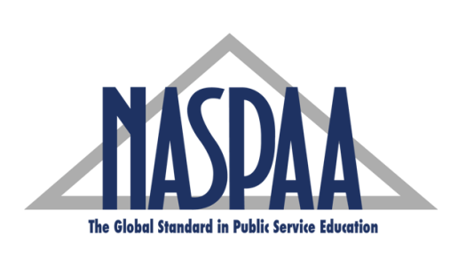
ANNUAL DISSERTATION AWARD
2019 NOMINATION FORM

(One nomination per NASPAA member program)

Our institution is nominating the following dissertation as one that has made a significant contribution to the research in the field of public affairs, public policy, public administration and public management. This dissertation was defended between July 1, 2018 and June 30, 2019. (Please print or type)

Name of Institution: _____________________________________________________________

Student’s Name: _____________________________________________________________

Email address: _____________________________________________________________

Ph.D. or DPA: _____________________________________________________________

Dissertation Advisor: _____________________________________________________________

Dissertation Title: _____________________________________________________________

_____________________________________________________________________________________

_____________________________________________________________________________________

___________________________________________________________________________
Signature of Dissertation Advisor – required

___________________________________________________________________________
Name and Signature of NASPAA Principal Representative – required

_______________________
Date

Email a copy of the completed dissertation and abstract in MS Word format to awards@naspaa.org by June 3, 2019. Include in the subject line “Dissertation Award Nomination for <Student’s Name>”.

