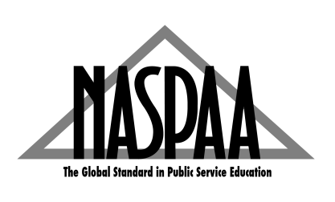
2019 #NASPAACareer Professionals Conference Registration
December 4-6, 2019, San Diego, CA
Hosted by UC San Diego School of Global Policy and Strategy (GPS)
First name:
Last name:
Title:
University:
School/Department:
Email:
Specific dietary needs or accessibility needs:
Is this the first NASPAA Career Conference that you are attending? ___Yes ___No
If yes, check here _____ to be matched with a 'buddy' who has previously attended the conference.
Will you attend dine-arounds on Wednesday, December 4th, from 5 to 7 pm in La Jolla Shores area?
___Yes ___No
Will you be attending the Reception on Thursday, December 5th from 5:30- hosted by Maximus?
___Yes ___No
Will stay for the Friday afternoon sessions (noon-3:30)? : ___Yes ___No
How long have you been involved in Career Services in the public service field?
___ 0-1 year
___ 1-3 years
___ 3-5 years
___ 5-10 years
___ More than 10 years
Are you interested in moderating a panel discussion? ___Yes ___No
Are you interested in facilitating a Best Practice session (small group session, approximately 20 minutes, to share an overview of a program/event/best practice from your school/office): ___Yes ___No

PAYMENT
TOTAL AMOUNT DUE: ___$185* ____$210
Mail your registration form and payment to:
NASPAA
1029 Vermont Ave, NW, Suite 1100,
Washington, DC 20005
___ Check enclosed, payable to NASPAA.
___ P.O # ________________________

*Registration form must be emailed to Monchaya at wanna@naspaa.org before November 4, 2019 (11:59 PM EST) to receive an early-bird registration rate of $185.

Questions about the conference: Contact Leigh Anne Elliott at 202-628-8965 ext. 115 or elliott@naspaa.org.

