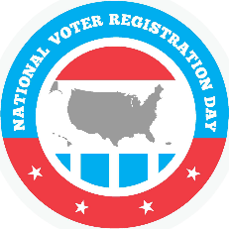
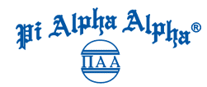
Pi Alpha Alpha Mini-Grant Application

PROPOSAL COMPONENTS

STATEMENT OF NEED
NASPAA believes our students should be leaders in civic engagement and have their voices heard in the public policy process. Join us in encouraging public service students across the country to register and vote in the upcoming elections by hosting a National Voter Registration Day event on your campus!
PROJECT DESCRIPTION
Pi Alpha Alpha (PAA) chapters who wish to apply for a grant to assist in conducting a National Voter Registration on their campus may apply for a mini-grant.
BUDGET
Grants are available for $200. Please note: NVRD provides toolkits and other resources for organizations holding events. Materials for publicizing the event do not have to be developed from scratch.
ORGANIZATION INFORMATION
Each proposal must indicate the name of the PAA advisor and contact information.
CONCLUSION
Applicant must provide a statement which includes project goals and expectations. NASPAA will be recognizing all schools who host a National Voter Registration Event on their campus during the Annual Fall Conference and encourages chapters who host an event to take pictures.
CRITERIA
- NASPAA member school in good standing and associated local PAA chapter that has inducted students within the last 12 months.
- A winning chapter may reapply the following year, however preference will be given to new applicants.
- Awards will be based on:
  - Adherence to proposal requirements
  - The project draws in various stakeholders to support desired outcomes
  - Preference will be given to applicants who intend to measure the success of their event.

Proposals submitted by the deadline of 11:59pm on Friday, August 28, 2020 will be considered. Submission by email to drudy@naspaa.org.

