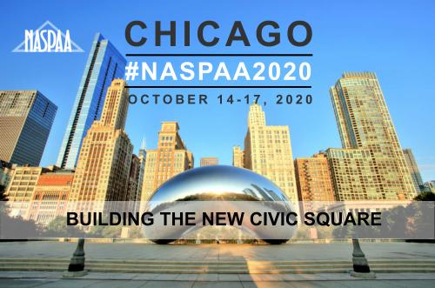 | 2020 NASPAA ANNUAL CONFERENCE PANEL PROPOSAL SUBMISSION FORM

- Title of Panel:

- Short summary of your panel here. This will be printed in the conference program and you will have a chance to edit it. (100 word max):

- Enter a more detailed description of your panel here. This will be shared with the conference committee to be used in the selection process, but it will NOT be printed in the program.
(400 word max):

- Convener: (name, email, organization)

- Panelists: (name, email, organization)
1.
2.
3.
4.
5.

- Tracks: (Pick one)
__Track 1: Research and teaching: What is the new civic education?
__Track 2: Impact and Engagement: What are programs and NASPAA doing in this space?
__Track 3: Inclusion in a New Civic Square
__Track 4: The new civic square globally: What it means around the world
__Undergraduate Education
__OTHER

- Which of the following topics is the main focus of your proposal? (Pick one)
__ Accreditation  __ Assessment  __ Budget and Financial Management  __ Comprehensive Schools  __ Diversity and Social Equity  __ Doctoral Education  __ Emerging Trends  __ Executive Education  __ Global Issues | __ Local Government Management Education  __ New Directors  __ Nonprofit Management Education  __ Research  __ Small Programs  __ Sustainable Development  __ Teaching and Learning  __Technology  __ Undergraduate Education  __ Not applicable

- Do you have formal endorsement from a NASPAA section or committee for this proposal?
(NOT REQUIRED) (Check all that apply)
__ Budget & Financial Management  __ Comprehensive Schools  __ Data  __ Diversity & Social Equity  __ Doctoral  __ Election Administration  __ Emergency Management and Homeland Security  __ Executive MPA  __ Healthcare  __ International  __ JPAE | __ Local Government  __ Marketing  __ Nonprofit Management  __ Pi Alpha Alpha  __ Policy Issues  __ Research  __ Small Programs  __ Standards  __ Undergraduate  __ Urban Serving Universities  __ None

- Are you a SPAE member and submitting a TPAC proposal?
__Yes __No

- Are you requesting that NASPAA sends a survey to members on your behalf to gather information for your panel? Note that requiring a survey of members may reduce the likelihood of panel acceptance:
__Yes __No

- Are you requesting audio visual equipment for your presentation (in addition to the standard laptop/projectors setup)?
__Yes __No __Unsure

- Is there any specific time that you would not be available to present on Thursday 10/15 or Friday 10/16 of the conference? Note: limits on scheduling flexibility might reduce the chances for the proposal’s acceptance:

- Is there anything else you want to share with the Conference Selection Committee?

- It is NASPAA’s policy that all sessions are open press. If you have concerns about your policy being open, please identify them below so we can discuss further:

Please submit your proposal online at https://naspaa.ps.membersuite.com.
Deadline: Tuesday, March 31, 2020 at Midnight EST.
If you have questions, please contact event manager Elliott@naspaa.org.

